Business Vision

منصه داجن (Dajin Portal)

User Stories

**Prepared by:** Samia Shabaan

**Prepared for: Dajin Portal**

**Last Updated: 21 September 2021**

**Creation Date:21 September 2021**

# Epic1(Farmer registration) : User story 1

## Description:

As A new Farmer I want to be able to register an account so that I can access Dajin portal

## Business Logic:

1. Farmer download App or from Portal
2. Open registration screen
3. Farmer enter registration data

* Name
* Address
* Contact details
* ID copy
* Activity type
* poultry farming type
* breeding breed
* Farms No
* Farm capacity
* Attachments
* Invitation code
* Interests

1. Farmer enter password
2. Farmer reenter password again.
3. System save farmer with status pending on approval
4. System send to the Farmer verification code (user story2)
5. After enter success verification code . system change farmer status to verified.

## Data Dictionary:

|  |  |  |  |  |
| --- | --- | --- | --- | --- |
| **Filed Name (EN)** | **Filed Name (Ar)** | **Data type** | **Mandatory** | **Comments** |
| **Name** | اسم المربي | String | Yes |  |
| **Address**   1. **Gov** 2. **City** 3. **Area** 4. Detailed address | العنوان   1. المحافظة 2. المدينة 3. المنطقة /الحي 4. العنوان التفصيلي | 1.       Lookups  2.       Lookups depend on Gov  3.       String  4.       String  5.       String | yes |  |
| **بيانات الاتصال**   * 1. Mobile no   2. Email   3. Facebook account   4. What ‘up | 1. التليفون 2. البريد الاليكتروني 3. حساب الفيس بوك 4. الواتس اب | 1.       number(11)  2.       String (email format)  3.       String(char50)  4.      Number(11) | 1.Yes  2.Yes  3.No  4.No |  |
| **Password** | كلمه المرور | string "capital, small, numbers, special chr" | Yes |  |
| **Reenter Password** | اعاده دخول كلمه المرور | Match password |  |  |
| **ID No** | صورة البطاقة | Number (14) | Yes |  |
| **Activity type** | نوع النشاط | Radio button | Yes | فردي ، شركة |
| **Poultry farming type** | نوع التربية | **L**ookup  Multiselect | **Yes** | أرضي ، بطاريات |
| **breeding breed** | سلالة التربية | lookup  Multiselect | Yes | أبيض ، ساسو ، فيومي ، بط ، حمام ، سمان |
| **Farms No** | عدد عنابر التربية | Number | No | من 1 – 100 |
| **Farms capacity** | سعه العنابر | Lookup | No | أقل من 1000  أقل من 5000  أقل من 10000  أقل من 100000 |
| **attachments** | المرفقات | Images(PNG, PDF, JPG) max 5mb | No |  |
| **Invitation code** | كود التوثيق | String(10) | No |  |
| **interests** | الاهتمامات | Lookup(multiselect) | No |  |

Validation:

1. The system must display a success message after creation
2. Farmer Enters Farmer User Account Information
3. If during Create Account, the system determines that the Farmer entered invalid *User Account* information, the following occurs:

* The system describes which entered data was invalid and presents the Farmer with suggestions for entering valid data.
* The system prompts the Farmer to re-enter the invalid information.
* he Farmer re-enters the information and the system re-validates it.
* If valid information is entered, the Farmer Account Information is stored.
* If invalid information is entered, the Entered Information is Invalid alternative flow is executed again. This continues until the Farmer enters valid information, or chooses Cancel (see the User Cancels Account Management Request alternative flow).

1. Invalid *User Account* information:

* Missing information items
* Missing error message appeared to customer
* Mobile or Email already exists in the system
* The system displays a message indicating that this is an active Farmer account.
* *User Account* information entered does not comply with its definition in the data validation table
* Not well formed e-mail address

1. Problems on Internet Connection

* Warn the Farmer about the problem with a message
* The screen is back to the main screen of Register New Farmer

1. Farmer Cancels registration
   * At any time, the Farmer may choose to cancel the account creation. At which point, the processing is discontinued, and the Farmer is notified that the account management request has been cancelled.

# Flow:

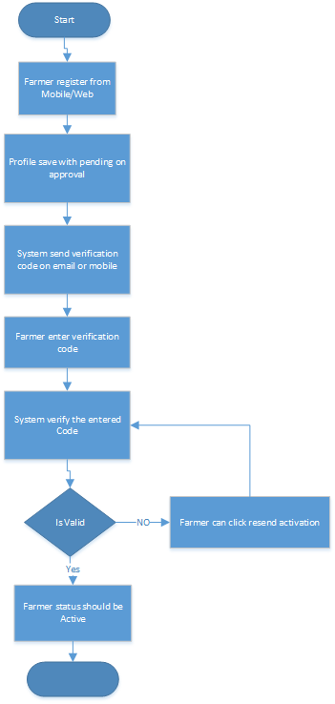

# Epic1(Farmer registration) : User story 2

## Description:

As A new Farmer I want to be able to verify my mobile no so that I can continue my account creation(registration)

## Business Logic:

1. System will send verification code (one time password) to farmer
2. Farmer should enter verification code
3. System validate the code
4. If the code is correct then Mobile will be verified
5. Else Farmer can Resend Verification code in case he didn’t receive code

Data Dictionary

|  |  |  |  |  |
| --- | --- | --- | --- | --- |
| **Filed Name (EN)** | **Filed Name (Ar)** | **Data type** | **Mandatory** | **Comments** |
| **Verification code** | الرمز التحقيقي | Number (4 or 6) | Yes |  |

## Validation:

1. If code is not valid message should appear “verification code is not valid”
2. Verification code will expire in configured time ( ex 30 sec, 60 sec)